**Name of Project: Book a Cruise**

Semester: Spring 2019

Group Number: 1

Team Members: Randall Byrd, Riyazh Dholakia, Syed Kalam, Sujal Patel, Biprojoyti Paul

Date of Submission: February 1st, 2019

**Brief Resumes:**

**Riyazh Dholakia**:

Georgia State University pursuing a bachelor’s in computer science. The languages I frequently use: Java, Swift, HTML, and CSS. The frequent software’s I use: XCode, Net Beans, and Visual Studio Code. I also interned as a Product Manager at Cox Automotive. I have worked on few iOS apps and websites also, that can be shown on my GitHub.

**Randall Byrd**:

Georgia State University Undergraduate student in Computer Science. The languages that I am inclined in are Java, C, and Python. The software’s I use are: Visual Studio code, and Eclipse. I made a simple chat room (implemented in C) with Unix/Ubuntu Systems.

**BiproJyoti Paul:**

I am a student at Georgia State University. My major is Computer Science. I like to make some front-end application on my free time. For this, I use HTML, CSS, JavaScript. The software that I use: Visual Studio Code, Eclipse, Visual Studio, XCode. I just got a remote internship at Good Mood. Some of my front-end applications can be found on my GitHub (Bipro 723).

**Syed Kalam:**

My name is Syed, and I’m a Junior at Georgia State University. I'm pursuing my bachelor’s degree in Computer Science.  In the course of my classes I've been familiarized with many languages. I prefer using Java for coding and SQL database for the back-end data. I have also learned how to operate Visual Studio, and currently I'm also learning Android Studio to make android apps. Along with my studies, I work part time at a company, Aasdel Corporation as a sales manager. I'm responsible for managing the inventories in their system and satisfying the customers with the product quality.

**Sujal Patel:**

I am a student at Georgia State University pursuing a bachelor’s in computer science. The languages I have experience with, Java, C++ and HTML. The software I use is Visual Studio, Android Studio, Eclipse.

**Scheduling and planning:**

**Work Breakdown Structure**

|  |  |  |  |  |  |  |
| --- | --- | --- | --- | --- | --- | --- |
| **Assignee Name** | **Email** | **Task** | **Duration (hours)** | **Dependency** | **Due date** | **Note** |
| Riyazh Dholakia (**Coordinator**) | rdholakia1@student.gsu.edu | Creating the GitHub repository as described in the assignment, and make assigned table to assign tasks to everyone, Write personal brief Resume, submit assignment | 3 hours | GitHub, everyone to finish task so I can submit it | 01/27/19 | Please send everybody GitHub repo invite. |
| Sujal Patel | spatel287@student.gsu.edu | Create GitHub Project tab (To Do, In Progress, and Done),  Create readme, commit pdf to GitHub, Write personal brief Resume | 3 hours | GitHub, assigned table | 01/31/19 | Make sure GitHub project board tasks are complete. |
| Randall Byrd | rbyrd11@student.gsu.edu | Do the System Requirements task, and put the final pdf together for submission, Write personal brief Resume | 3 hours | Assigned tasks, wait until everyone finishes their task to put together project | 01/31/19 | Remind everyone to do a final push to GitHub docs. |
| Syed Kalam | skalam1@student.gsu.edu | Do the teamwork basics and answer the questions, Write personal brief Resume | 3 hours | Assigned tasks, reading book | 01/31/19 |  |
| Biprojoyti Paul | bpaul5@student.gsu.edu | Do the problem statement and answer the questions, Write personal brief Resume | 3 hours | Assigned tasks | 01/31/19 | . |

**Teamwork Basics:**

Teamwork is a concept of many individuals working together cooperatively to achieve a common goal. Working together allows everyone to recognize their skills and share their opinions with one another. Not all team members agree with every opinion, in this case, they should talk to each other and provide feedback and other alternatives. At the end of the discussion, the members take a vote for which option will work the best for the team. Being a part of a team doesn't mean you are competing with one another, rather you work together and help each other. As an example, when I was in the previous class, I was part of a team project, and one of the team members was stuck at writing a java code. Rather than ignoring the team member, I stepped up and helped him figure out the code.  A team member should be committed to the team and participate evenly in all parts. A successful team carries characteristic that include having a common goal that is agreed on together as a team. Communicating among each other and collaborating with the team will help individuals to learn new skills from one another. Teamwork makes it easier and faster to achieve a goal, rather than working individually on a given task. As an example, from my workplace, we must do the teamwork where we all have different tasks to performed, but in the end, we have to come up one result. One day my worker needs a help in the warehouse, so I helped him out and prove that we all have to look up each other’s stuff and solve the problems together which makes perfect teamwork. To complete the task successfully and satisfactory, communication and collaboration are the main elements. Getting to know each other and working together as a team is the key. If any of us feels uncomfortable or overmuch with his task, that person can share or work with other team members. The team coordinator can but not required to play the role as a facilitator if a squabble comes out. Work Norms, the work for the project are distributed equally between team members based on individual strengths. Deadlines are set by Manuel for this assignment. If a group member fails to complete their designated task, the group shares their concern with the member and encourages this person to complete the task. All group members check one another’s work to ensure productivity. If there is a difference of opinion with when tasks should be completed, the group members should communicate concerns directly with the other team member. Facilitator Norma, the facilitator is usually the team coordinator for the team who was chosen by the professor, but each person in the group has the role of facilitating when needed. This role is responsible for coordinating communication and helping team members solve problems. The facilitator should motivate members who are struggling with a task.

Communication Norms, there should be constant communication with the team members to ensure that all of the work is being done in a timely manner. The team’s communication is done through Slack and Groupme. For handling difficult behavior, when a team member acts timidly or is shy it is best to ask the group members questions directly. Speaking to the person directly will allow them an opportunity to answer so that they do not feel steamrolled by other members. The facilitator and other members should encourage communication so that no one feels left out or shy about speaking up.If a member of the team is annoyed or has an unreasonable complaint about another group member, the facilitator or another group member should remind the offended person that the project is meant as a learning experience. They should expect mistakes to be made. If there is a legitimate complaint, make it known to the person that their behavior is affecting the group’s productivity.

**Communication and Collaboration:**

**Readme page**

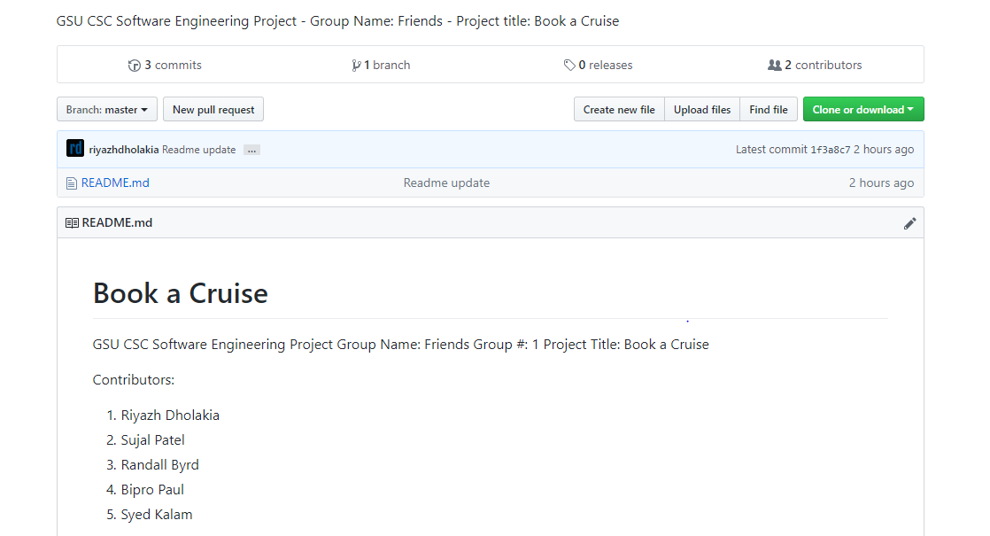

**Project page**

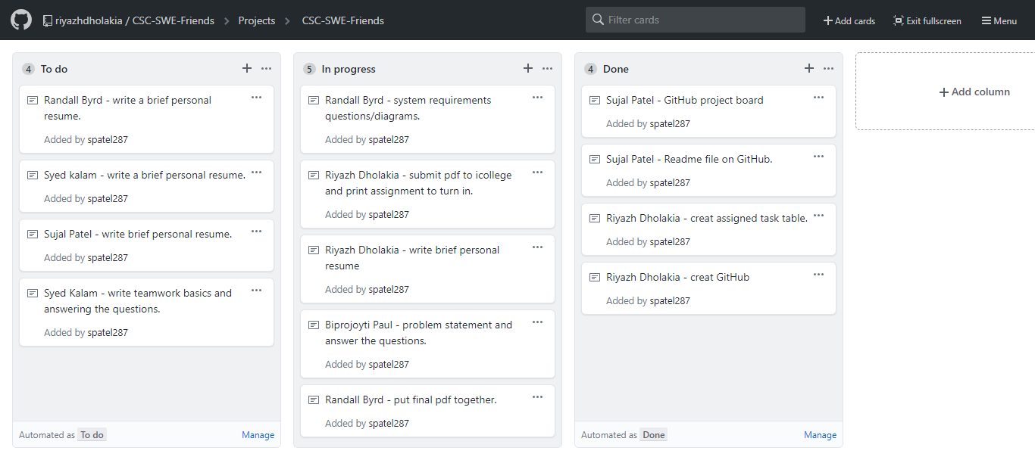

**Problem Statement:**

What is your product, on a high level?

Book a Cruise.

* Whom is it for?

People who want to go on vacation, have fun, new experience, explore the world, love being on a boat, traveling, food, etc. There are many reasons to go on a cruise. It is also better price wise, compared to flying. Some people feel safer on water rather than flying to places. The audience is endless. The audience can also be controlled by the market and the client. Our product will shift towards what way the client wants and has designated a target audience. Clients in our case will not choose an audience and keep it open for everyone.

* What problem does it solve?

Sometimes it is hard to find a cruise booking place. Nowadays, many people want to go to their desired place and wanted to be close to the water and be with the family. The valuable thing is that the cruise gives them all things to a reasonable price. Cruise trips the best trips ever, that incorporate boats, attractions, clubs, family games, and more. Hopefully, this website also sets expectations for other websites in the future and other companies can implement a friendly and easy navigation site like ours.

* What alternatives are available?

People can book plane, car, or go by train, bus, but the fact that Cruise is different than others, tells you more people are will experience this. Anybody would love to be part of an amazing scenery and experience. Other alternatives can also be to book from competitors’ site. There are many out there, but not ones that can easily guide you through like ours.

* Why is this project compelling and worth developing?

There is not a lot of competitor in the market for this project. The way we are developing it, so you know there is room for growth. These days it is a social trend to go the Cruise. You can visit many beautiful Islands. The food experience is different when on a cruise, and the staffing team is from all over the world. This also can be used for other project examples. Specifically, UX friendly website, that is easy to navigate.

* Describe the top-level objectives, differentiators, target customers, and scope of your product.

The top-level objective is building a product to officiate, booking a cruise. Differentiators from other products is out will be simple, better UX, and other various packages other competitors do not offer. Scope of our product is to keep it basic but useful as possible to meet all our requirements. Our audience base is open to anyone so it can be simple and easy to book.

* What are the competitors and what is novel in your approach?

There is a lot of websites and apps already been made on this project. If somebody Googles, they will find many different places to book cruises. We have seen a lot of websites where the look of the website does not appeal as much so that the customer will not be impressed to book the cruise from their website Our Novel approach will be make the front-end look really nice so that it can appeal customer and quick and easy booking for them. Example of an competitor website is Expedia. Other competitors can also be car rentals, airplane, bus, and many more.

* Make it clear that the system can be built, making good use of the available resources and technology.

We must make a front-end and back-end/database which will connect to each other. We think we have enough resources to make that possible. If we need help, we can use Google, YouTube, and Udemy courses to sharpen our skills. The front-end system we can built by HTML, CSS. To make it responsive we will use some jQuery. For database we will use Firebase. On backend we will use node, JavaScript, hopefully Firebase will take care of server.

* What is interesting about this project from a technical point of view?

It will be fun and challenging to make such kind of project. The fact that we can build a system, which can book ticket with given customer information will be mind blowing, and we can use it later any similar system if we want. This technical idea is common process, hopefully we can introduce new tech into the scene. This is also help us build our skills and gives a good resume project. These skills help us in our future career.

**Section 5: System Requirements**

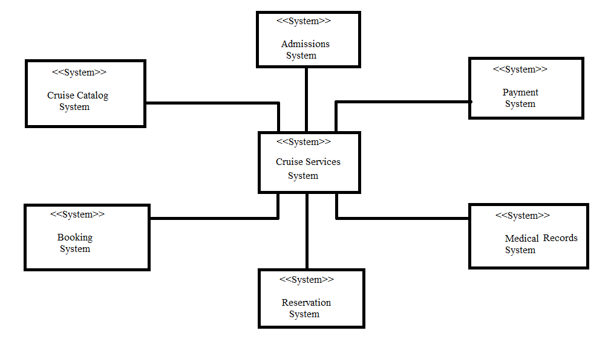

In this context model the Cruise services system is the main system connected to various systems in its environment: The payment system generates payments made out from the clients to the main system. The medical records system keeps track of customers medical records, for example if a cruise is to go out of the country then appropriate shots are needed to be on file. The admissions system keeps track of customers’ accounts, and reviews new customers. The cruise catalog system is a list of all the available cruises in the system, and the booking system allows clients to book their desired cruise.